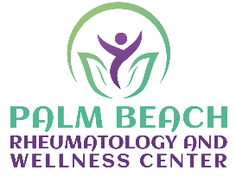

Dear Palm beach rheumatology and wellness center patients,

The health and wellness of our patients is our top priority, and therefore, limiting the spread of COVID-19 in our community and among our most vulnerable members is of the utmost importance.
Palm Beach Rheumatology and Wellness Center will remain open as long a it is safe and in compliance with State and Federal recommendations. We currently will adhere to the following procedures:
- If you are having a medical emergency, you must call 911 or go directly to your closest Emergency Room.
- Any patient with cough and fever will be asked to schedule a Telemedicine Visit (Virtual Visit) with Dr.Khan to triage their risk and give appropriate guidance on further testing. Any patient that is tested should isolate themselves at home until results are processed and resulted.
- Any patient with general health issues or other acute illnesses may still be seen in the office by scheduling an appointment.
- Any patient who is uncomfortable coming into the office because of their risk for exposure, can schedule a Telemedicine visit with Dr.Khan.
- Non-urgent issues such as medication refills and lab result questions should be directed to the patient portal. It is impractical for Dr.Khan to call each individual patient, but we will try to accommodate through Telemedicine visits or issues that cannot be addressed through the patient portal.
- Again, patient with emergent issues requiring immediate attention must call 911 or go immediately to the closest emergency room.

Additionally, all patients are encouraged to continue to adhere to the guidance from the Centers for Disease Control (CDC) to limit transmission of COVID-19 including but not limited to the following:

- Frequent handwashing/ use of hand sanitizer with at least 60% alcohol
- Isolation at home if you are having fever
- Covering your cough.
- Those with direct exposure to known positive persons should isolate themselves at home for 14 days.

We appreciate you trusting Palm Beach Rheumatology and Wellness Center with your health and wellness. Please feel free to contact the office with question or concerns.

Sincerely,
Palm Beach Rheumatology & Wellness Center

